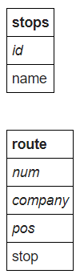

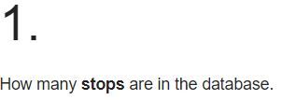

**SELECT COUNT(*) FROM stops**



**SELECT id FROM stops WHERE name = 'Craiglockhart'**



**SELECT id, name FROM stops JOIN route ON stops.id = route.stop WHERE num = '4';**

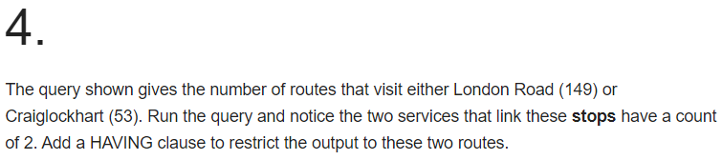

**SELECT company, num, COUNT(*) FROM route WHERE stop=149 OR stop=53 GROUP BY company, num HAVING COUNT(*) = 2;**



**SELECT a.company, a.num, a.stop, b.stop FROM route a JOIN route b ON (a.company=b.company AND a.num=b.num) WHERE a.stop=53 AND b.stop=149**

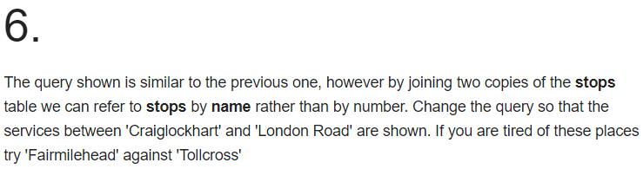

**SELECT a.company, a.num, stopa.name, stopb.name FROM route a JOIN route b ON**

**(a.company=b.company AND a.num=b.num)**

**JOIN stops stopa ON (a.stop=stopa.id)**

**JOIN stops stopb ON (b.stop=stopb.id)**

**WHERE stopa.name='Craiglockhart' AND stopb.name = 'London Road'**



**SELECT DISTINCT a.company, a.num**

**FROM route a JOIN route b ON**

**(a.company =b.company AND a.num=b.num)**

**JOIN stops stopa ON (a.stop=stopa.id)**

**JOIN stops stopb ON (b.stop=stopb.id)**

**WHERE stopa.name='Haymarket' AND stopb.name='Leith'**



**SELECT DISTINCT a.company, a.num**

**FROM route a**

**JOIN route b ON (a.num=b.num AND a.company=b.company)**

**JOIN stops stopa ON (a.stop=stopa.id)**

**JOIN stops stopb ON (b.stop=stopb.id)**

**WHERE stopa.name = 'Craiglockhart' AND stopb.name = 'Tollcross'**

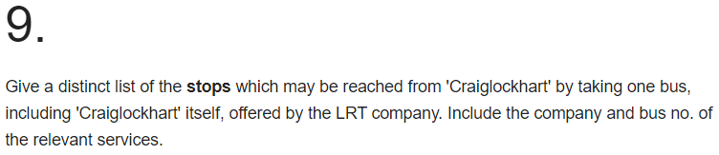

**SELECT stopb.name, a.company, a.num**

**FROM route a JOIN route b ON (a.company = b.company AND a.num = b.num)**

**JOIN stops stopa ON (a.stop = stopa.id)**

**JOIN stops stopb ON (b.stop = stopb.id)**

**WHERE stopa.name = 'Craiglockhart';**